A Project Report
On

Leak detection in water distribution networks
BY
Siripuram Suchandra
2018B1A20529H

Under the supervision of
Prof. K SRINIVASA RAJU
SUBMITTED IN PARTIAL FULLFILLMENT OF THE REQUIREMENTS OF
CE F376: DESIGN PROJECT



BIRLA INSTITUTE OF TECHNOLOGY AND SCIENCE PILANI (RAJASTHAN)
HYDERABAD CAMPUS
(MARCH 2022)

ACKNOWLEDGMENTS

I would like to use this opportunity to express my gratitude to everyone who supported me during this project. I would like to thank Prof. K SRINIVASA RAJU for providing me with the opportunity to work on this project. I am sincerely grateful to him for sharing is views on the number of issues related to this project. I would like to extend my heartfelt gratitude to bits pilani university for allowing me to work on such brilliant projects. I would also like to thank everyone who directly or indirectly was involved in providing me with this opportunity

Birla Institute of Technology and Science-Pilani,
Hyderabad Campus

Certificate

This is to certify that the project report entitled “Leak detection in water distribution networks” submitted by Mr. SIRIPURAM SUCHANDRA (ID No.2018B1A20529H) in partial fulfillment of the requirements of the course CE F376, Design Project Course, embodies the work done by him under my supervision and guidance.

Date: 02-05-2022 Prof. SRINIVASA RAJU K
BITS- Pilani, Hyderabad Campus

ABSTRACT
Leaks are major source of water wastage occurring around the planet. In this project we attempt to predict a leak in a water distribution network from the values of pressure and flow rate. we use a benchmark data set called leakDB to simulate A water distribution network and get some values of pressure and water flow rate over a period of time in periodic intervals. We can observe whether a leak has happend according to the change in flow rate and pressure. We try to get this pattern and use them to predict the leaks using machine learning. We use a one dimensional convolutional neural network to classify weather the given network has a leak or not.

CONTENTS
Title page……………………………………………………………….1
Acknowledgements……………………………………………………..2
Certificate……………………………………………………………....3
Abstract………………………………………………………………....4
Contents…………………………………………………………………5

1. Introduction 6
2. Convolutional Neural Network 7
Architecture: 8
Input Layer: 8
Convolution Layer: 8
Pooling Layer: 8
Fully Connected Layer: 9
3. Numerical: 10
4. LeakDB Database: 15
5. Model: 17
6. Code: 19
Data: 19
Coding the Model: 21
Importing the libraries required: 21
Reading and Data Prepocessing: 21
Making the CNN Model: 22
Representation of Model: 22
Compiling and Running the Model: 22
Ploting the decrease in loss function of the Model: 23
Predicting the leaks with the test dataset: 23
Performance Metrics of the Model: 24
7.Results: 24
7. Conclusion: 25
8. References 25

1. Introduction

Leaks in water distribution network is a major problem and an source of obstacle for the goal of conserving water so not to deplete our already scarce water resource. A regular household can lose up to 400 litres of water per day due to leaks in their pipe network. So a mechanism to detect leaks aor predicting leaks can save a lot of water all around the world and it helps in maintaining a proper water distribution network. We can detect a leak in a pipeline from various different methods like sound acoustic data from the pipeline infrared image sensing and so on. forever project we are taking the values of water flow rate and pressure at various points in the pipeline network. read encoded data into a machine learning algorithm for this project we are using a convolutional neural network to train the model such that provided the information of president water flow rate we can predict if a leak will happen or not. The convolutional neural network can be better than other machine learning algorithms like multilayer perceptron network due to local sharing of weights which reduces the number of parameters required to run the model which leads us to make the model with reduced probability of overfitting hand and due to this we can also make the model a deep neural network model. The data we use in this project is obtained from a benchmark data set called leakDB which gives us the values of pressure and water flow through a simulated network of water distribution pipes over a period of time like weeks months and years through a fixed time period.

2. Convolutional Neural Network

Convolutional neural network (CNN) is a type of feed-forward artificial neural network and can be generalised as a multilayer perceptron network (MLP). The first CNN was made by David Hubel and Torsten Wiesel in 1959 to recognise visual patterns which was further developed by Dr. Kunihiko Fukushima in the 1980s. [1]

The first modern CNN model which is the basis of CNN’s architecture is LeNet made by Yann LeCun in 1998 whose basic model is like in Figure 1

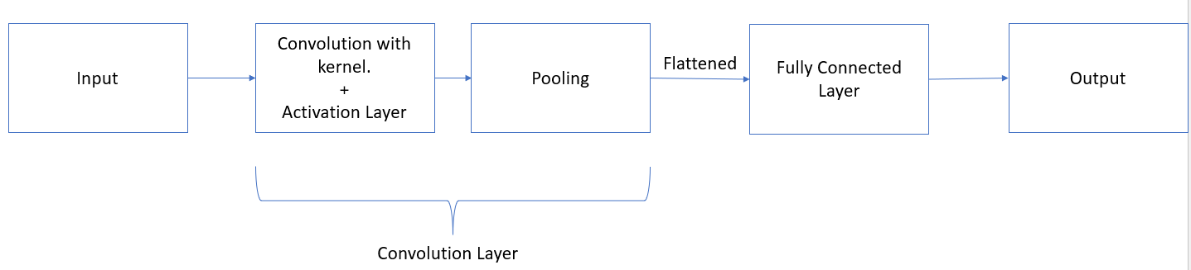
Figure 1 CNN Architecture
To train a CNN model we need a training set and a testing set of data. These sets of data have various inputs and labelled outputs. In both sides of data, the output is manually labelled by a number to each input. For example, an image of a dog could be labelled as one and the image of a cat as zero, so we train the model in such a way that if we upload a picture of a dog we get the outcome as one after the processing in the model and for a cat we get the output as zero.

The CNN model’s parameters are randomized and then they're changed based on the error value calculated by passing the training set through it. After minimising error value, the model is tested for its accuracy using the testing set.

Architecture:

A convolutional neural network (CNN) will consist of an input layer, hidden layer (convolution layers, pooling layers, fully connected layers) and an output layer.

Input Layer: In the CNN the input is a tensor matrix i.e any generalised matrix.

Convolution Layer:
The layer consists of a filter called kernel and an activation layer if necessary.

The kernel is a matrix that traverses across the input data by the specified stride, performs a dot product with a sub-region of the input data, and returns the output as a matrix of dot products.

The activation layer is layer that performs an activation function (like ReLu) to each input and gives the output.
For a 2x2 kernel and stride 1 the convolution is:
O₁ |  | O₂
O₃ |  | O₄
I₁₁ | I₁₂ | I₁₃
I₂₁ | I₂₂ | I₂₃
I₃₁ | I₃₂ | I₃₄

K₁₁ | K₁₂
K₂₁ | K₂₂
X

O1 = I11*K11 + I12*K12 + I21*K21 + I22*K22 + b
O2 = I12*K11 + I13*K12 + I22*K21 + I23*K22 + b
O3 = I21*K11 + I22*K12 + I31*K21 + I32*K22 + b
O4 = I22*K11 + I23*K12 + I32*K21 + I34*K22 + b

Pooling Layer:
By merging the outputs of neuron clusters at one layer into a single neuron at the next layer, pooling layers minimise the dimensionality of data. There are two types of pooling that are commonly used: maximum and average. The maximum value of each local cluster of neurons in the feature map is used in max pooling, while the average value is used in average pooling.
In pooling layer, we should define the dimension and the stride of pooling layer
For a pool of size 2x2 with stride 1
I₁₁ | I₁₂ | I₁₃
I₂₁ | I₂₂ | I₂₃
I₃₁ | I₃₂ | I₃₄
O₁ |  | O₂
O₃ |  | O₄

O1 =Max (I11, I12, I21, I22) [For max pool] or Avg (I11, I12, I21, I22) [For average pool]
It is similar, for O2,3,4.

After the operations the n dimensional layer is flattened to a matrix of one column with n*n rows.

Fully Connected Layer:
Every neuron in one layer is coupled to every neuron in another layer in fully connected layers(Figure 2). It works in the same way as a multilayer perceptron neural network (MLP). To classify the data, the flattened matrix passes through a fully linked layer.

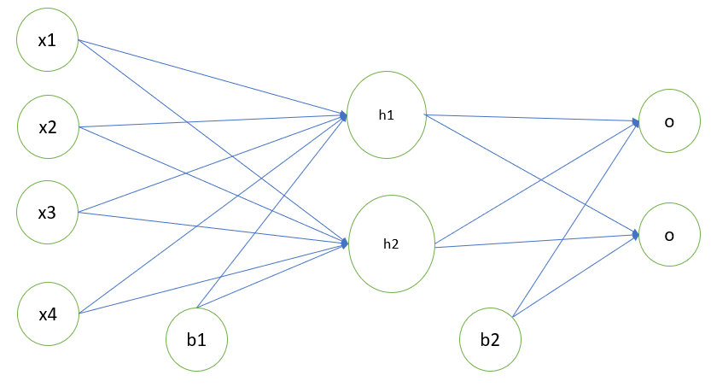
Figure 2 An example of fully connected layer

3. Numerical:
In this example we consider the problem as calculating the output for one set of data from a data set. Here for the given input the expected output is zero so after running the model we calculate the error and adjust the weights and biases by back propagation method

Input:

1 | 0 | 1 | 1 | 0
1 | 1 | 0 | 1 | 1
0 | 1 | 1 | 1 | 1
0 | 0 | 0 | 0 | 0
0 | 1 | 0 | 0 | 0
X
Filter/Kernel (K):3x3 matrix with stride 1
1 | 1 | 0
0 | 0 | 1
1 | 0 | 1

1st Convolutional Layer:
2.3 | 1.3 | 1.3
1.3 | 2.3 | 1.3
1.3 | 2.3 | 2.3
Input x Filter + b₀ =

Max Pooling: 2x2 with stride 1
2.3 | 2.3
2.3 | 2.3

Flatten Layer & Dense/Fully Connected Layer:

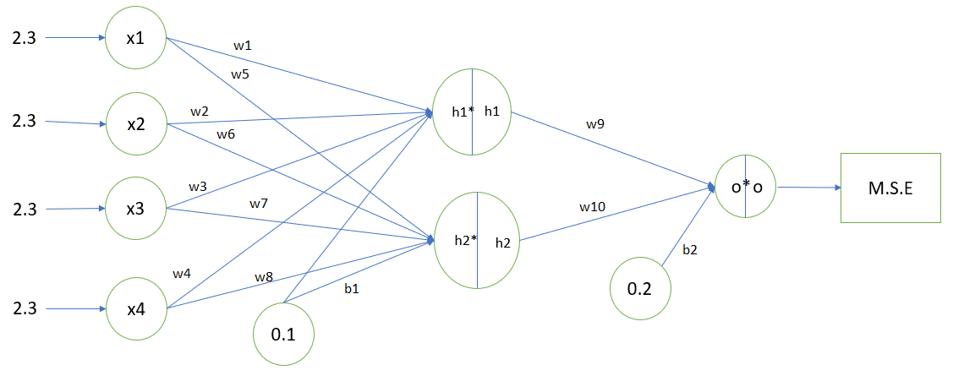
Figure 3 The Dense Layer of the numerical
Weights and Biases:
The weights inside the kernel are randomized.
We have one bias for each kernel filter. For our case its b₀ = 0.3
In the dense/fully connected layer we have
10 random weights (w₁ = 0.9, w₂ = 0.8, w₃ = 0.7, w₄ = 0.6, w₅ = 0.5, w₆ = 0.4, w₇ = 0.3, w₈ = 0.2, w₉ =0.4, w₁₀ =0.5)
and 2 random biases (b₁ = 0.1, b₂ = 0.2)
Activation Function:
In a neural network, an activation function specifies how the weighted sum of the input is turned into an output from a node or nodes in a layer.
The activation function used in this case is sigmoid activation function.
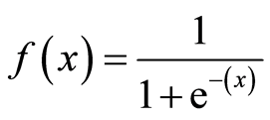

Error function:
The error function describes the difference between predicted and observed results. A large variation indicates that the model is not well fitted and that the weights should be modified.
The error function we use here is Mean Squared Error (M.S.E):
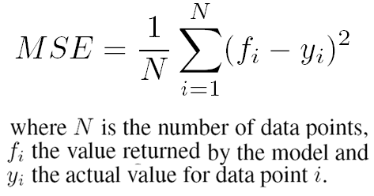

Learning Rate (α) = 0.5,
The learning rate is a hyperparameter that governs how much the model changes each time the model weights are changed in response to the predicted error.

Target: Value expected = 0

Forward Propagation:
h₁* = x₁w₁ + x₂w₂+x₃w₃+x₄w₄+b₁ = 7.0
h₂* = x₁w₅+x₂w₆+x₃w₇+x₄w₈+b₁ = 3.32
h₁ = sigmoid(h₁*) = 0.99
h₂ = sigmoid(h₂*) = 0.97
o* = h₁w₉ + h₂w₁₀ ₊b₂= 1.081
o = sigmoid(o*) = 0.71
M.S.E (c) = (0.71 – 0)² = 0.504

Back Propagation:
Backpropagation is the neural network training algorithm. Each of the weights is assigned a random value at the start. This model produces a projected result, which is then compared to the actual result. The error function is used to calculate the variation. The slopes of the absolute partial derivatives of the error function with respect to weight (δc/δw) are utilised to help us identify and modify the error and weight.
So, the goal is to minimize cost function, in this case M.S.E. So, we must find gradient of all the weights and biases with the error function using chain rule.
For example:
δc/δw₁₀ = δc/δo * δo/δo* * δo*/δw₁₀ = $2\left(o-t\right)×[o×\left(1-o\right)]×h_{2}$ = 0.28
similarly
δc/δw₉ = 0.29
δc/δw₈ = δc/δw₇ = δc/δw₆ = δc/δw₅ = 0.01
δc/δw₄ = δc/δw₃ = δc/δw₂ = δc/δw₁ = 0.003
δc/δb₁ = 0.006
δc/δb₂ = 0.292

0.006 | 0 | 0.006
0.006 | 0.006 | 0.006
0 | 0.006 | 0.006
δc/δK =

We then calculate the new weights by w_{i}(new) = w_{i}(old) – (α * δc/δw_{i})
0.997 | 1 | -0.003
-0.003 | -0.003 | 0.997
1 | -0.003 | 0.997
So,
K =

w₁ = 0.898, w₂ = 0.798, w₃ = 0.698, w₄ = 0.598,
w₅ = 0.495, w₆ = 0.395, w₇ = 0.295, w₈ = 0.195,
w₉ =0.255, w₁₀ =0.36
b₀ = 0.297, b₁ = 0.097, b₂ = 0.054,
So, the network would be updated as shown in Figure 4 and Figure 5:
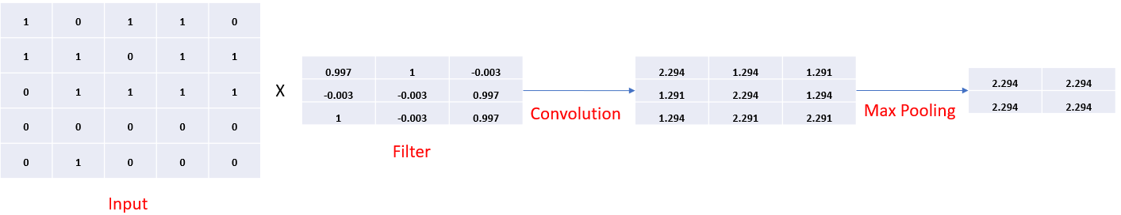
Figure 4 Part – 1 of updated model

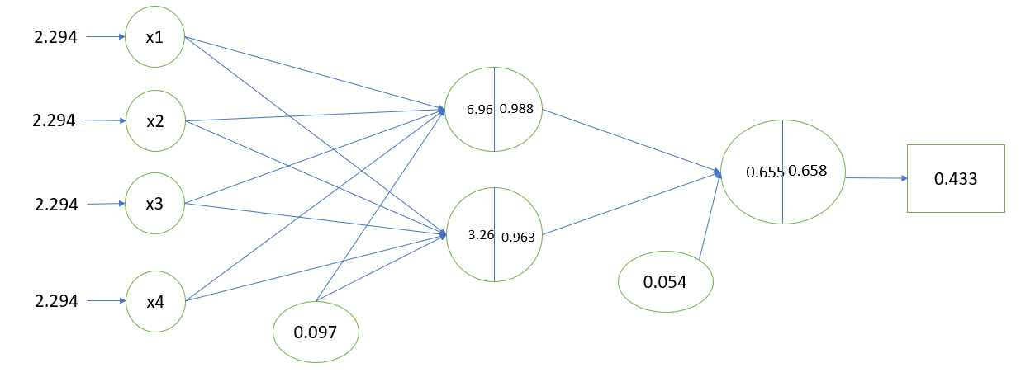
Figure 5 Part – 2 of updated model
We can see here that the error of the model has reduced for this training case so we can back propagate again for this case our go to other inputs from the data set to adjust the weights again to get my least error possible for every input
After we go through every input from the training data set we input data from the testing set check the accuracy of the model
The accuracy of the model is given by

$$Accuracy=\frac{Correct Predictions}{Total Predictions}$$
The video explanation till here can be obtained at https://drive.google.com/drive/u/1/search?q=seminar%201

4. LeakDB Database:

Vrachimis produced LeakDB in 2018 utilising the python library Water Network Tool for Resilience and EPANET, which was widely utilised in the investigation of the hydraulic features of water distribution networks. [2]
This dataset rests has two different architectures of water distribution networks: Net-1 and Hanoi.Their architecture is shown in Figure 6
Net-1 is a simple, small, and virtual WDN architecture, used for small-scale testing. It consists of nine nodes, one reservoir, and one tank.
Meanwhile, Hanoi is a simplified architecture of the real WDN from the city of Hanoi (Vietnam). It consists of one reservoir, 32 nodes, and 34 pipes.

Figure 6 The architectures of water distribution networks used from LeakDB: (a) Hanoi network; (b) Net-1 network. Source: [2]

The data it produced from both WDN is a time series data of Flow and Pressure values at nodes of the network. [3]
We can induce two two types of leaks in this networks. Abrupt leak and Incipient leak. The changes in flow and pressure when that happens is shown in below figure. Based on these patterns we can train the network.(Figure 7)
Figure 7 Variation of flow and pressure data for a leak. Source: [2]

5. Model:
Since the data from LeakDB is a time series data the model most suited will be a 1D convolutional neural network. We take 80% of data for training, 20% for testing.
In the model the convolutional layer receives the 1D signal/data as input for feature extraction. With learnable kernel filters, the convolutional layer detects local features at different places in the input feature map.

In comparison to an MLP-based neural network, the combination of local connectivity and weight sharing allows us to substantially reduce the number of free parameters, avoiding overfitting and allowing us to develop deep architecture..

The ReLU = max(0,x) activation function is used in all activation layers because it has been found to train CNNs faster and overcomes the vanishing gradient problem.

The model will have 2 convolution layer and 1 dense layer. We are trying to make the model as simple as possible to avoid over-fitting. (Figure 8)

The first convolution layer will have 64 kernels and each kernel is of the size 3 x 1 and we take a stride of 1. For the Max pooling operation the size of the pool is taken as 2 with a stride of 1.

The second convolution layer will have 32 kernels each kernel is of the size 3 x 1 and we take a stride of 1.For the Max pooling operation the size of the pool is taken as 2 with a stride of 1.

Then after flattening the output, pass it through a dense layer with 128 neurons/nodes and then get the output having 0 as non-leak and 1 as leak.

The cost function is binary cross entropy loss function i.e

E = Ʃ Ʃ t * logp, where t and p are target labels and the predicted outputs

The learning rate is 0.0001

So we backpropagate to minimize E.

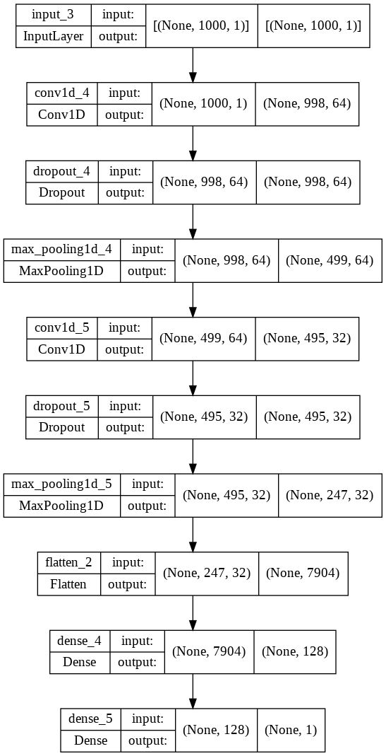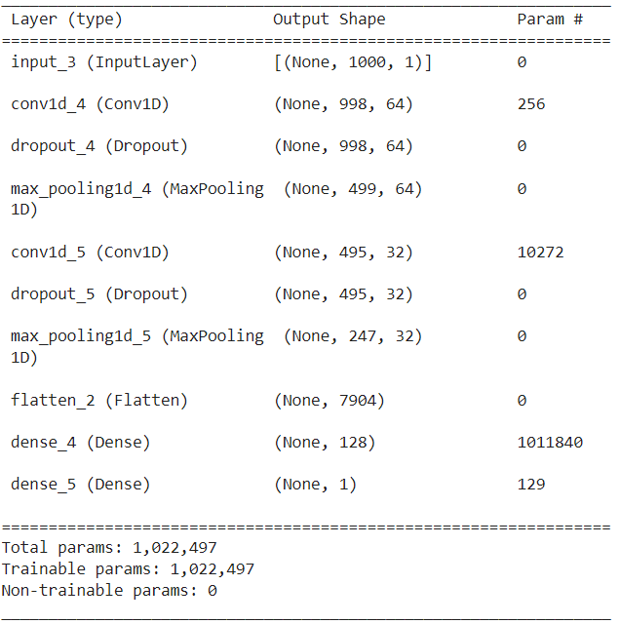

Figure 8 Details of Model
To judge the model we calculate correlation factor, MSE and RMSE.

6. Code:

Data:
The leak data is generated from leakDB dataset. From this dataset using the Net-1 model, I generated 1000 scenarious in the model in which some has leaks and others don’t.(Figure 9)
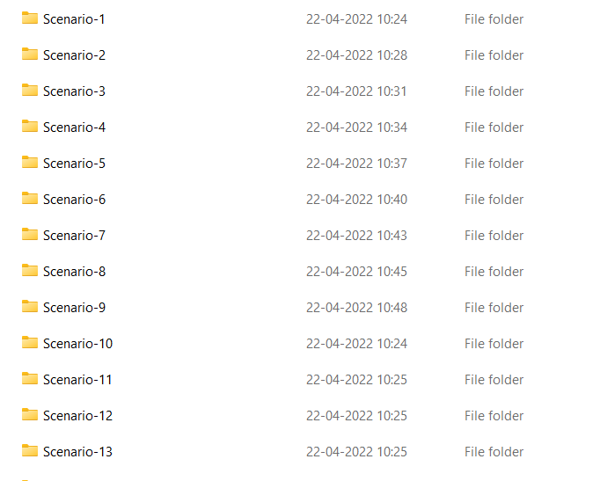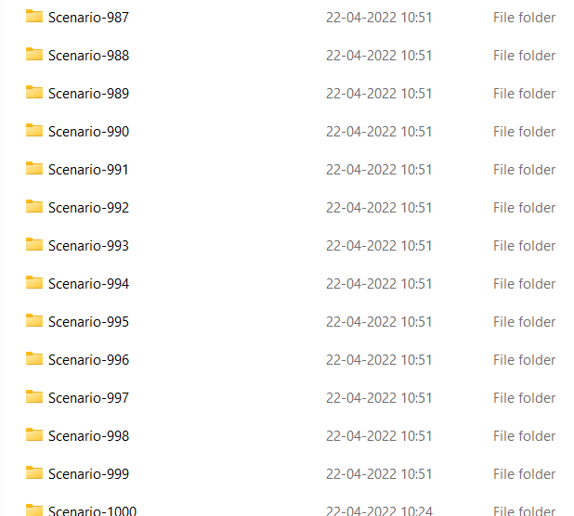
Figure 9: Scenarios Generated
Each scenario has data about it’s flow rate, pressure over different nodes and the leak demand if it has a leak.(Figure – 10 )
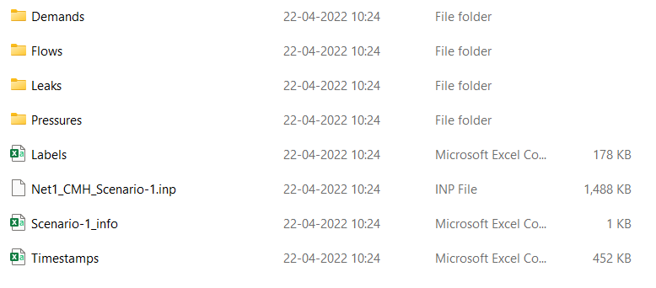
Figure 10: Data in each scenario
Each folder of flows and pressures in every scenario has its values given over various nodes/links (Figure 11)
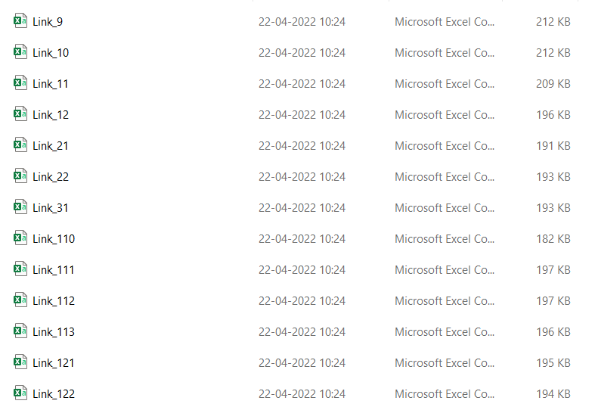
Figure 11: In each Flow/Pressure folders
I have combined flow and pressure data of each scenario into one .csv file and then in an combined file called ‘Data’, I took the values of each scenario into one row. So we have 1000 rows and 227000 columns. (Figure – 12 )For the code I have reduced the size to 1000 x 1000 while making sure the leak parts a present as the previous dataset is too huge to work with
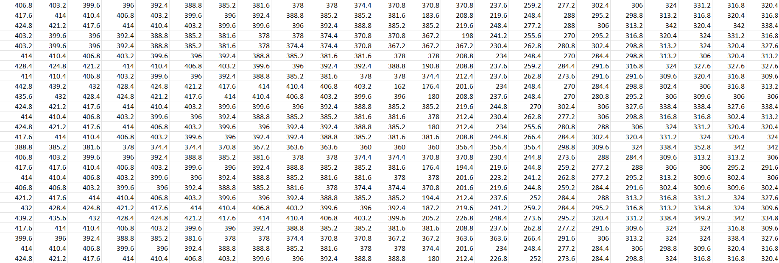
Figure 12: A snippet from Data.csv file
From leakDB we also get the outcomes of each scenario in a csv file. In the outcomes ‘1’ means leak in the model and ‘0’ means no leak in the model.(Figure – 13 )
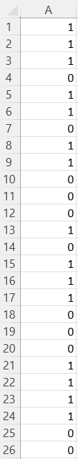
Figure 13: The output csv file

Methodology:
The coding is done in Jupyter Lab in python script using the keras library and tensorflow backend.

Importing the libraries required:
These libraries are made to run complex, multi-line codes with simple commands.
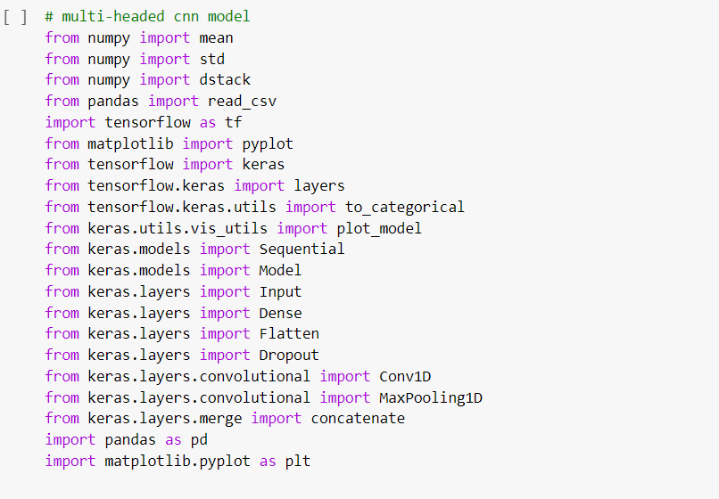
Figure 14

Reading and Data Preprocessing:
The data is in .csv format so for python to read it we have to use pandas library to read and store the data as a dataframe and them we convert it to an array using numpy library to deal with the data in more efficient way. Then we use dstack() to stack arrays in sequence depth wise (along third axis). We use that because in keras, the input dimension should be consisting of (num_samples, steps, feature_size).
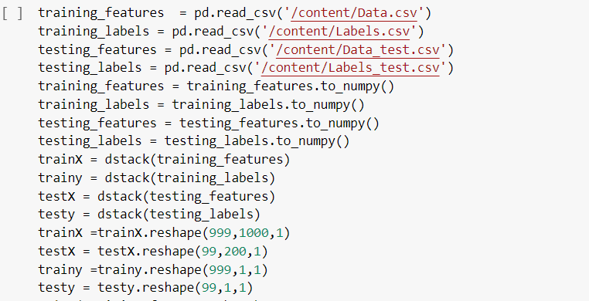
Figure 15

Making the CNN Model:
We, then made an CNN model using the functions in keras library to add 2 convolution layers, 1 dense hidden layer and 1 output layer and describing each function necessary for the model.
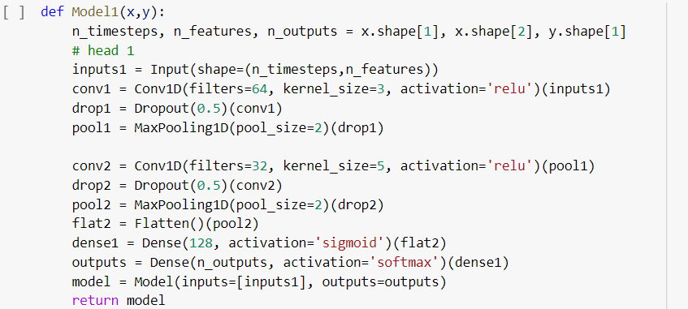
Figure 16

Representation of Model:
We can ge a pictorial representation of the model we made by running the functions mentioned in Figure 16,. The outputs are shown in Figure -8
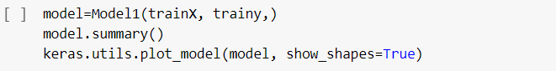
Figure 17

Compiling and Running the Model:
In this section of code, we mention the method used in back-propagation (Stochastic Gradient Descent),loss function, learning rate etc. and then run the model 1000 times to train it.
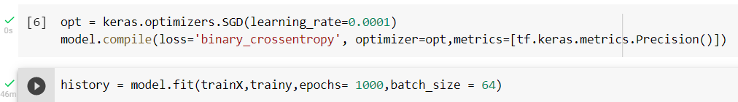
Figure 18

Plotting the decrease in loss function of the Model:
We can plot how the loss value is changing over each epoch. Our goal is to reduce it’s value . The output is shown in Figure 19
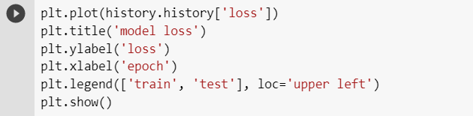
Figure 19
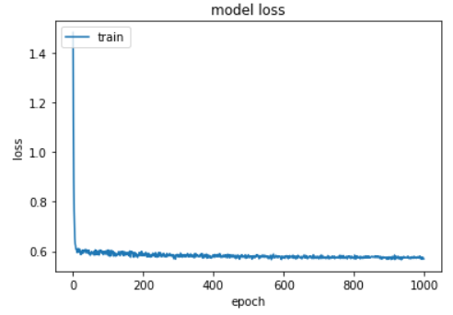
Figure 20

Predicting the leaks with the test dataset:
By using this function we make the trained model to predict the outputs by using the testing dataset


Figure 21

Performance Metrics of the Model:
To get a value for the performance of the model we use statistcal formulas to compare the predicted results of the model with correct outputs.
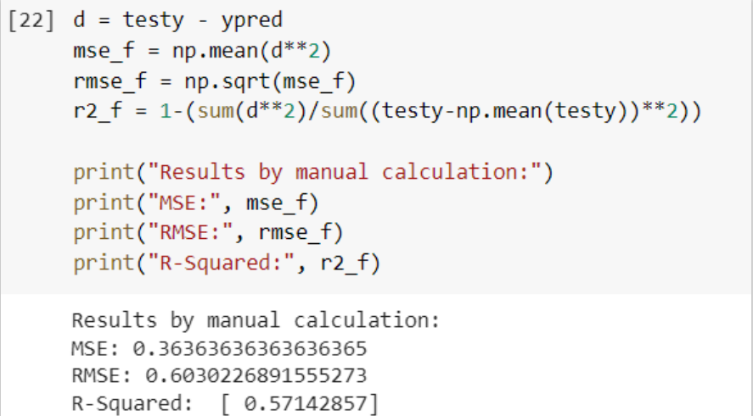
Figure 22

7.Results:

The performance of this model is calculated using 3 performance metrics R.M.S.E, R² and M.S.E.
$$M.S.E= \frac{1}{N}*\sum_{i=1}^{N}{{(y_{i}-y_{pred})}^{2}}$$
$$R.M.S.E= \sqrt{M}.S.E$$
$$R^{2}=1- \frac{\sum{{(y_{i}-y_{pred})}^{2}}}{\sum{{(y_{i}-y_{mean})}^{2}}}$$

The values of R.M.S.E, R² and M.S.E for this model are
Figure 23

7. Conclusion:

From using leaked data and machine learning techniques we can find a pattern between the change in pressure and flow rate with the status of leaks in the WDN. CNN is a model that can be used for better pattern recognition and high efficiency compared to other regular multi layer perceptron network because it has shared weights like kernels in the convolution layer, due to which the number of parameters required to process the data will naturally be less and since we are not applying other techniques for pattern recognition along with a model we reduce the noise coming from that techniques . The model in this paper is just a predictive model that might give a nice correlation factor. After running the model we get the R² value to be 0.571 which makes it a fair model but cannot be used in the field. The biggest advantage of utilizing CNN is it’s less dependence on pre-processing the data thereby decreasing the need of human intervention for developing the model’s functionalities. To make the model more accurate and precise about it’s predictions and to use the full superiority of CNN over other models, we should have more input data in the range of million data points but a normal processor cannot handle this much data and we should have more faster computing power to deal with more amounts of data to better train the model from the current state.

8. References

[1] Saad Albawi; Tareq Abed Mohammed; Saad Al-Zawi, Understanding of a convolutional neural network.DOI: 10.1109/ICEngTechnol.2017.8308186
[2] Maryam Kammoun, Amina Kammoun and Mohamed Abid,Experiments based comparative evaluations of machine learning techniques for leak detection in water distribution systems. Water Supply Vol 22 No 1, 628 doi: 10.2166/ws.2021.248
[3] Stelios G. Vrachimis , Marios S. Kyriakou, Demetrios G. Eliades, and Marios M. Polycarpou LeakDB: A benchmark dataset for leakage diagnosis in water distribution networks. 1st International WDSA / CCWI 2018 Joint Conference

[4] Y. W. Nam, Y. Arai, T. Kunizane and A. Koizumi, Water leak detection based on convolutional neural network using actual leak sounds and the hold-out method. Water Supply Vol 21.7 2021

[5] Mengfei Zhou , Zheng Pan, Yunwen Liu, Qiang Zhang, Yijun Cai, And Haitian Pan, Leak Detection and Location Based on ISLMD and CNN in a Pipeline. Digital Object Identifier 10.1109/ACCESS.2019.2902711

